**"Detective Guild of Athkatla" mod**

*By Scheele, Austin & Arcanecoast Team*

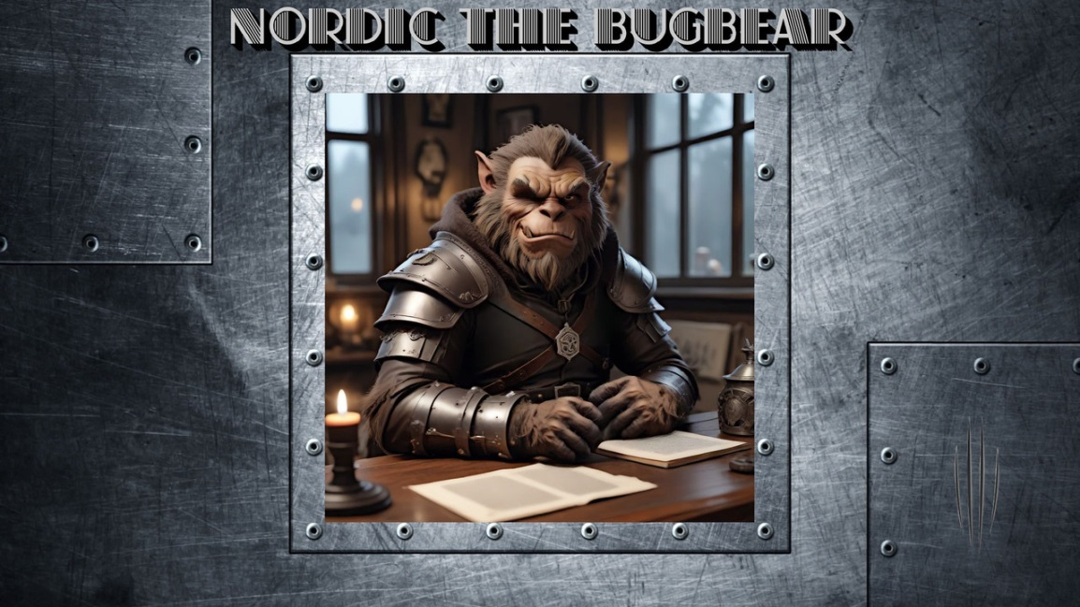

**DESCRIPTION:**

The mod adds a new detective guild building in the Slums area, which can become an additional stronghold for a player of any class - if he manages to save the guild from bankruptcy in two weeks of game time.

The quest will begin after meeting an unusual new character in the Council of Six building in the Government District.

You will find:

- a new two-story building (maps were created by Gorion);

- a new stronghold that will generate income;

- new non-joinable characters;

- one long quest to get a guild;

- small quests and incidents in the guild itself (to get some of them, you need to return to the building later);

- a small episode in ToB, if the guild was obtained in SoA.;

- several new items (mostly books, notes and things needed for the plot or just for immersion in history)

**COMPATIBILITY:**

On BG2EE, EET the mod works by default. On the "classic" version of the game (BG2, BGT) the mod will install only if the Infinity Animations mod is previously installed (since it requires bugbear animation in the game).

The mod should be compatible with any other mods, but conflicts with mods that change Mae'Var's guild are possible - "NPC Strongholds", "D0 Questpack (Additional Shadow Thieves Content component)", "Expanded Thief Stronghold". Sharing with them is at your own risk.

**CREDITS:**

**Scheele** – author of the idea and script text

**Austin** – coding, additions to the script

**Gorion** – maps of new locations

**Tipun** – technical assistance

**Alisia** – additions to the script

**Endarire** - proofreading of 233 lines of English guild text

Art objects:

nordic__bugbear_by_thatdman,

orc_by_michalsalatav2,

The Fixer by Smolin

**ANSWERS TO QUESTIONS**

***Will the mod work on the "classic" version of the game?***

It will, but only in conjunction with the Infinity Animations mod.

***How do I open the locked cabinet with documents in Adelard's office?***

Pay attention to the entry in the journal and to Nordic's words, and then select the desired date from several possible ones as an answer and type it in the MMYYYY format.

***Will new quests be added for the guild?***

An expansion of the mod is planned, if the coder has free time. We can't promise anything yet.

**VERSION HISTORY**

**v.1.1**. First release